Monitoring PaperCut NG System Health using Zabbix

You can use the third-party tool Zabbix ([www.zabbix.com](http://www.zabbix.com/)) to monitor the overall state of your print environment. This includes but is not limited to getting real-time updates on aspects such as device inactivity, outages, trends in printing resources and usage, etc.

* **Zabbix Server** – The Zabbix Server must already be installed and set up. For more information, see <https://www.thezabbixbook.com/>
* **Zabbix agent** – The Zabbix agent must be configured using the following steps:

Step One – Get the PaperCut NG System Health Monitoring details 2

Step Two – Access the Zabbix Server Admin web interface 3

Step Three – Import the Zabbix template for your PaperCut host 3

Step Four – Create a PaperCut NG host group on the Zabbix Server Admin web interface 5

Step five – Create a PaperCut NG host on the Zabbix Server Admin web interface 5

Step Six – Configure PaperCut NG host macros 6

Step Seven – Verify PaperCut NG System Health is monitored by Zabbix 7

## Step One – Get the PaperCut NG System Health Monitoring details

1. Log in to the PaperCut MF Admin web interface:  
   http://<PaperCut-Server-IP>:9191/admin
2. Navigate to **Options > Advanced**
3. In the **System Health Monitoring** section’s **Authorization - GET query parameter** fieldtake note of the following:
   * **The PaperCut NG Application Server authorization key:**  
     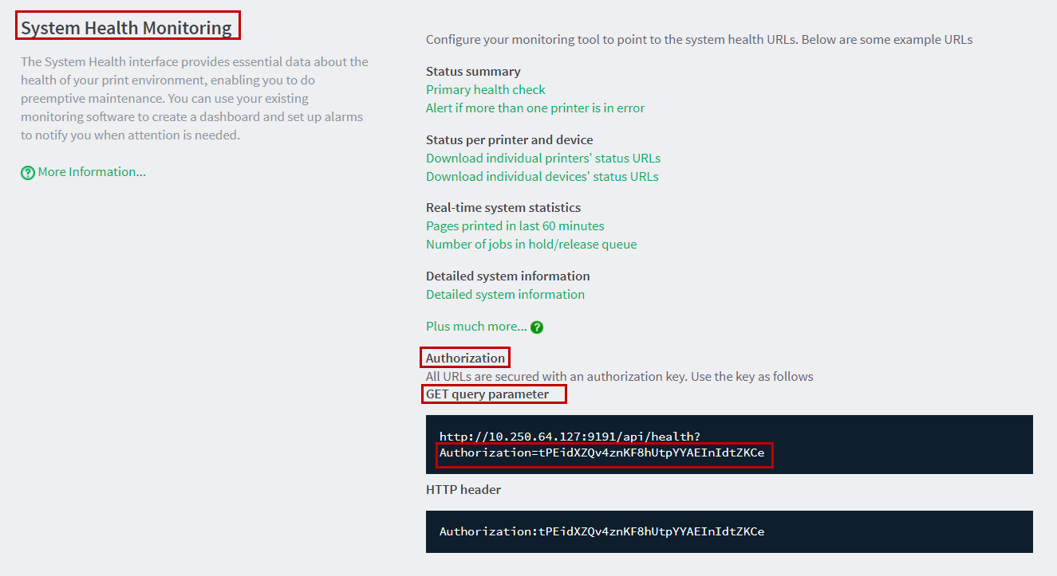
   * **The PaperCut NG Application Server IP address:  
     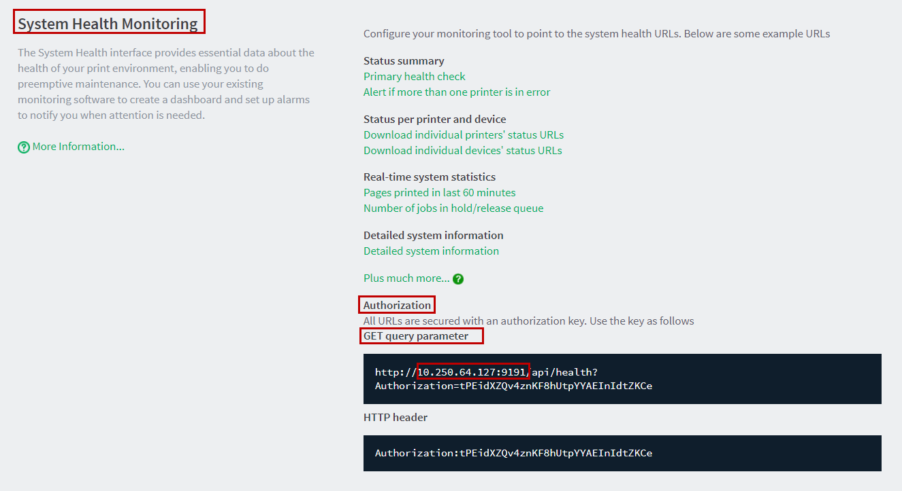**
   * **The PaperCut NG Application Server URL:  
     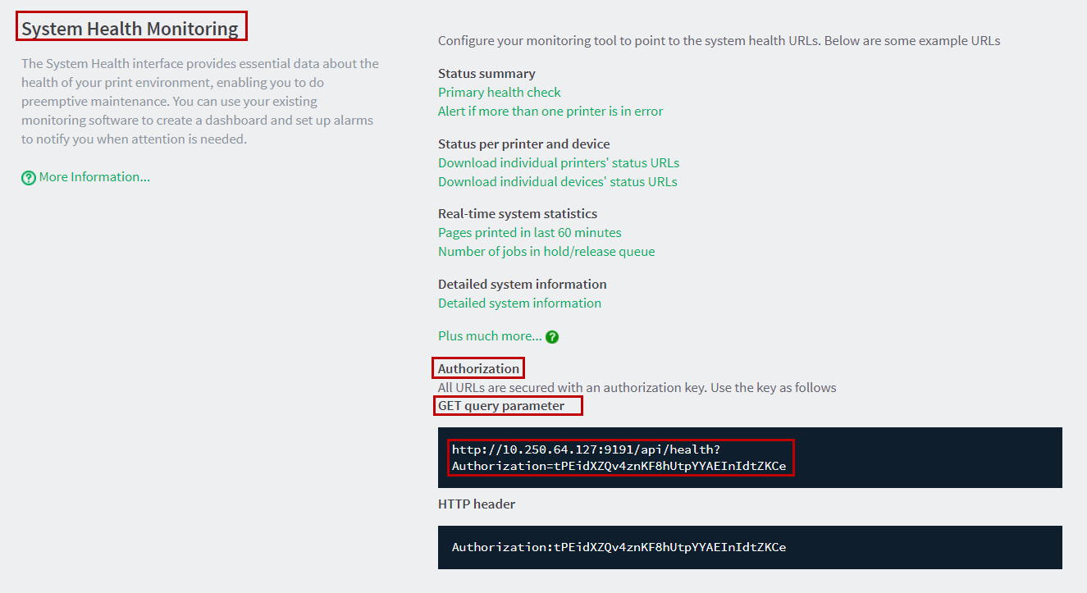**

## Step Two – Access the Zabbix Server Admin web interface

To access the Zabbix Server Admin web interface:

1. Log in to the Zabbix Server Admin web interface:   
   http://<server ip or hostname>/Zabbix
2. Enter the Zabbix Server Administrator credentials:   
   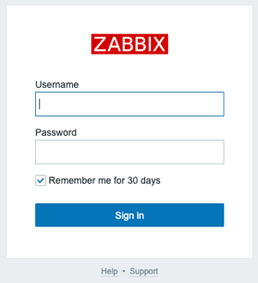
3. Click **Sign in**.

## Step Three – Import the Zabbix template for your PaperCut host

To import the Zabbix template for your PaperCut host:

1. Navigate to:   
   https://github.com/OpensourceICTSolutions
2. Right click the **template-papercut-http.yml** file and select **Save link as…**:  
   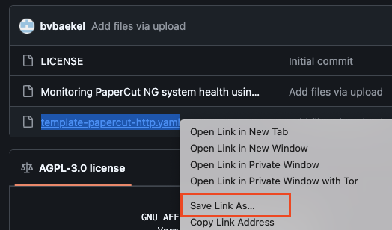
3. Save the file in to your local directory:  
   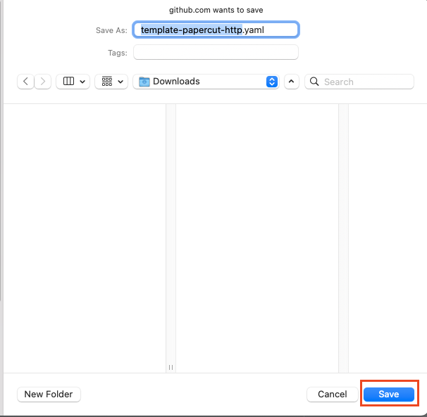
4. Access the Zabbix Server Admin web interface.
5. Navigate to **Data collection > Templates** and click **Import**:

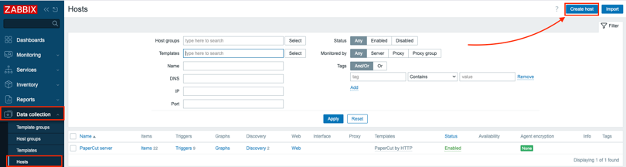

1. On the **Import file** field, click **Choose File**:
2. Locate and select the **template-papercut-http.yaml** file saved in your local directory and click **Open**:  
   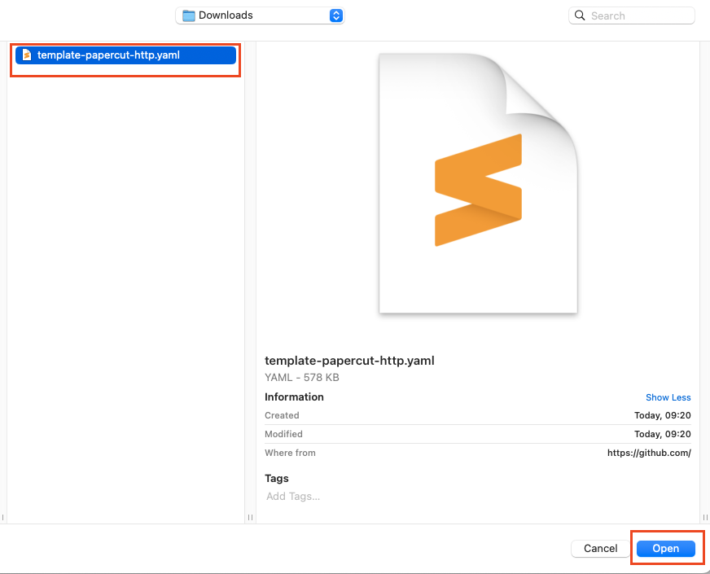
3. Verify that the **Import file** field displays the **template-papercut-http.yaml**file:  
   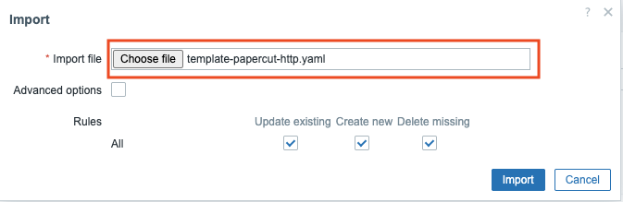
4. Do not change the default settings of the **Rules** fields and click **Import**:
5. Click **Import:**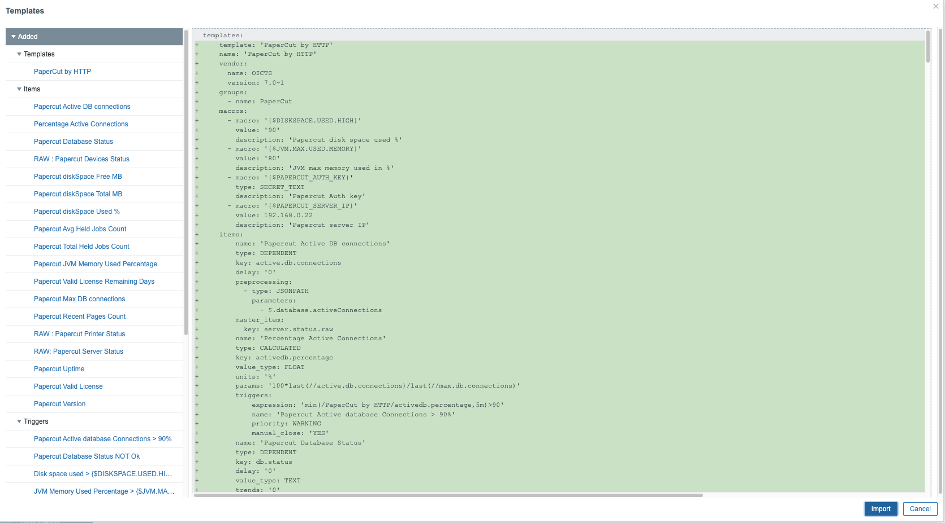
6. Your template **PaperCut by HTTP** is now imported in the template group **PaperCut**.

## Step Four – Create a PaperCut NG host group on the Zabbix Server Admin web interface

To create a PaperCut NG host group on the Zabbix Server Admin web interface:

1. Access the Zabbix Server Admin web interface.
2. Navigate to **Data collection > Host Groups** and click **Create host group**: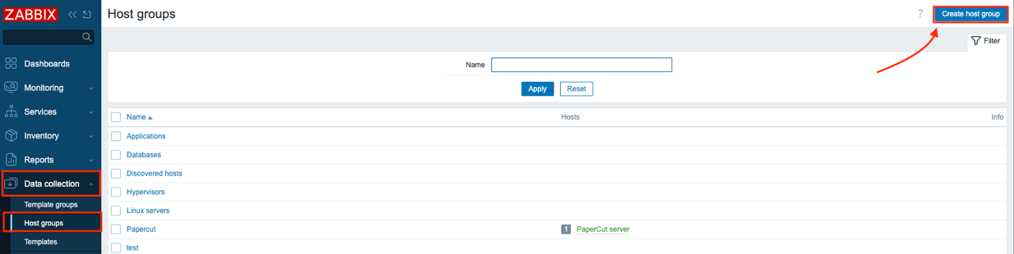
3. Enter the relevant **Group name** and click **Add**:

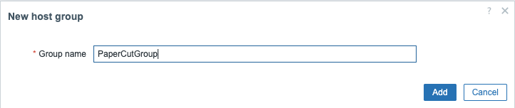

1. Verify that the PaperCut NG host group you just created is on the **Data collection > Host groups** page:

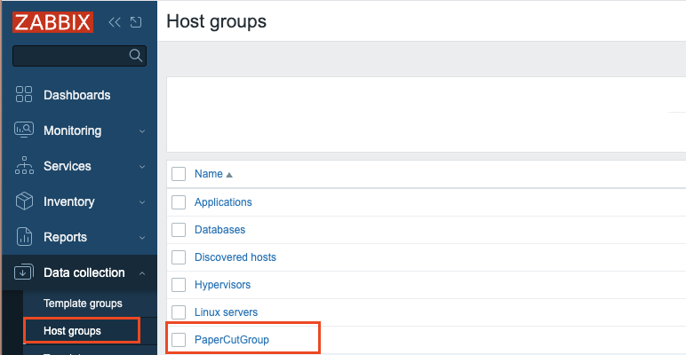

## Step five – Create a PaperCut NG host on the Zabbix Server Admin web interface

To create a PaperCut NG host on the Zabbix Server Admin web interface:

1. Access the Zabbix Server Admin web interface.
2. Navigate to **Data collection > Hosts** and click **Create host**:

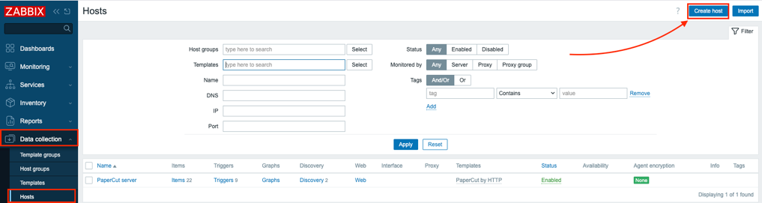

1. Change the default settings of only the following fields and click **Add**:

**Host name –** Name of your PaperCut NG Application Server (**The name can be anything you like**).

**Visible name** – Easily identifiable name of your PaperCut NG host on the Zabbix Server.

**Groups** – Select the PaperCut NG host group (you just created) from the **Other groups** list and click the **<** button, to add it into the **In Groups** list.

**Templates**: Type the name PaperCut by HTTP or use the Select box to search

**Agent interfaces** **IP address** – you don’t have to add any interfaces

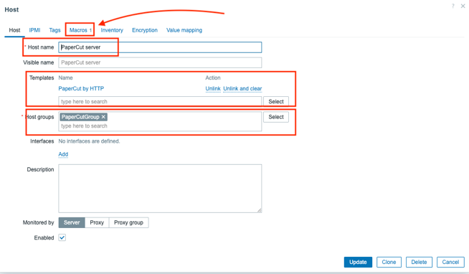

## Step Six – Configure PaperCut NG host macros

1. Before you safe the host click on the **Macros** tab on the top. 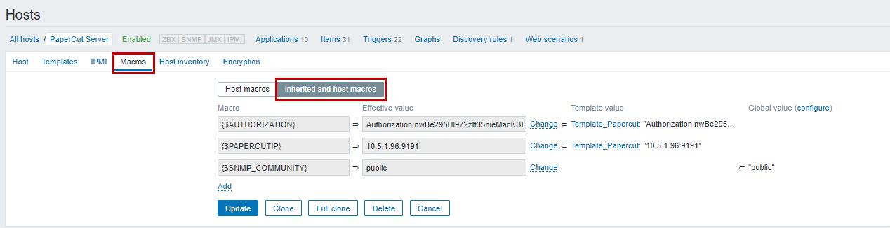
2. Navigate to **Macros > Inherited and host macros**:

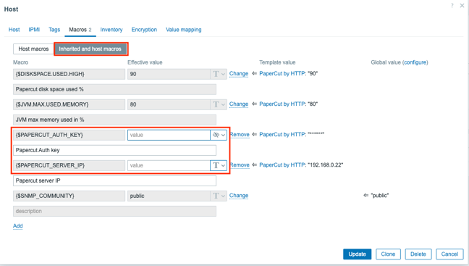  
**Inherited and host macros –** Select this box first then replace or fill in the macros. **{$PAPERCUT_AUTH_KEY} –** Papercut authorization key as seen on the advanced page. **{$PAPERCUT_SERVER_IP} –** IP of the papercut server as seen under the advanced page. **The 2 other Macros on top can be adjusted to your need. {$DISKSPACE.USED.HIGH} and {$JVM.MAX.USED.MEMORY}**

## Step Seven – Verify PaperCut NG System Health is monitored by Zabbix

To verify that your PaperCut NG System Health can be monitored by Zabbix:

1. Access the Zabbix Server Admin web interface.
2. Navigate to **Monitoring > Latest data**:  
   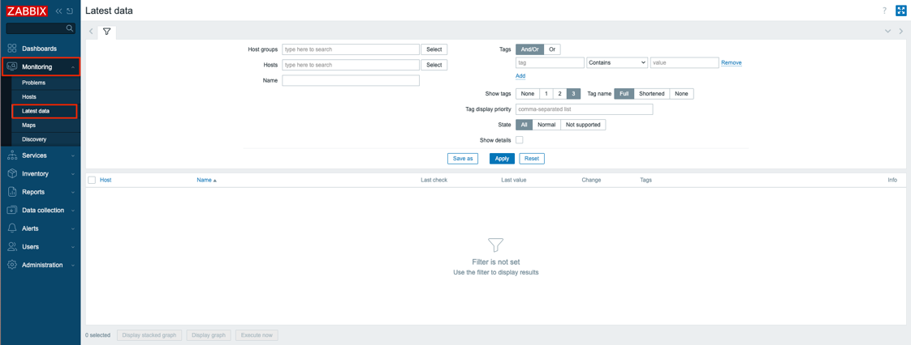
3. On the **Hosts** field, click **Select**:  
   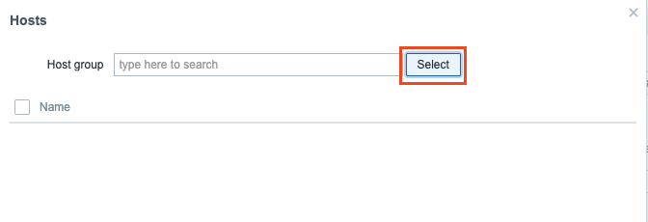
4. From the **Group** list, select the PaperCutGroup host group:  
   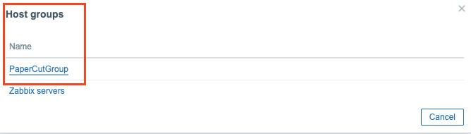
5. From the **Hosts** section, check the **PaperCut Server** option and click **Select**:   
   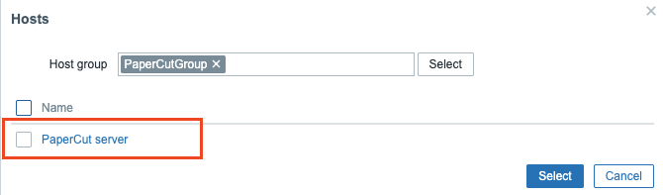
6. Click **Apply**:  
   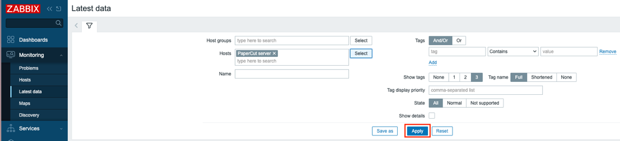
7. Verify that the most recent data from your PaperCut NG Application Server is displayed on the **Last check** and **Last value** columns:

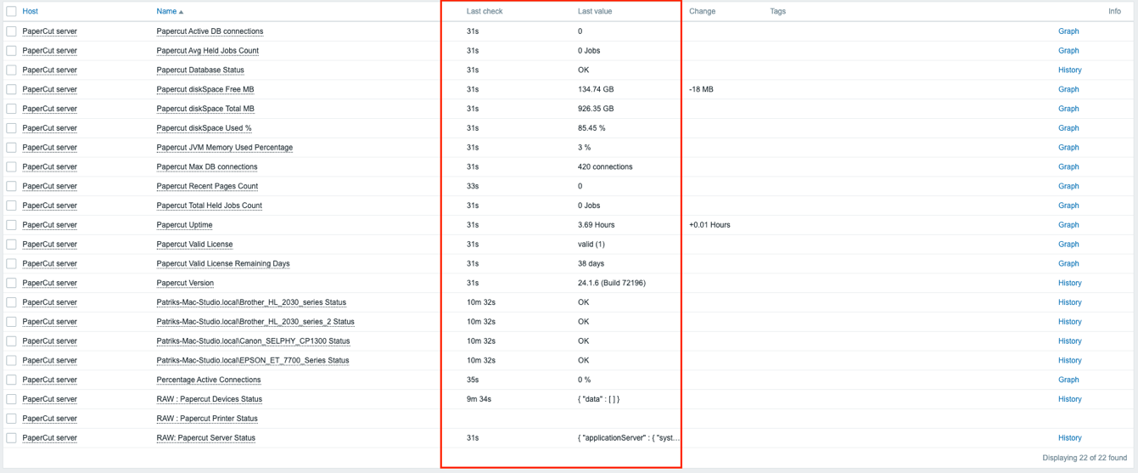

**Note**: Printers and Devices will be detected by name but it will take up to 1h before they will get any values. After this items will be populated when the status changes immediately.

1. Check the Papercut dashboard
   1. Navigate to Monitoring -> Hosts
   2. Select the **Dashboard** from the PaperCut server host.

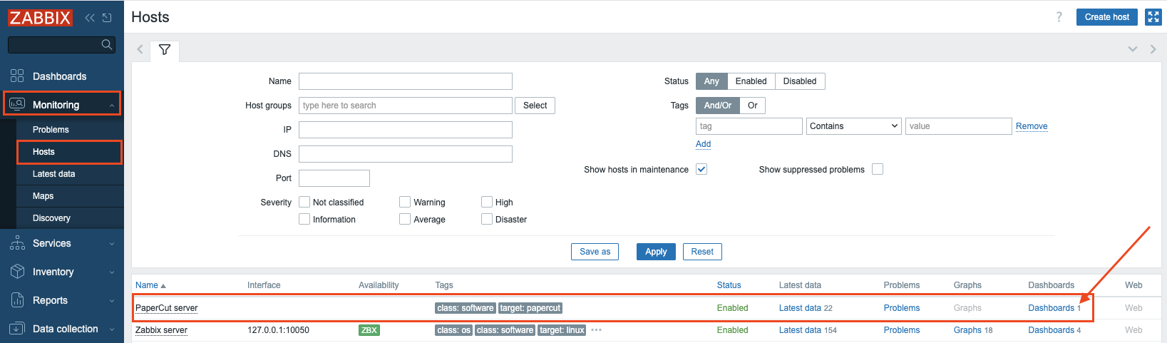

You will now have an overview of your Papercut server health state:

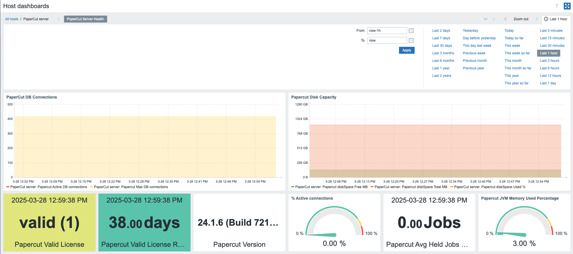

1. If you run into errors

**Note:** If the most recent data from your PaperCut NG Application Server is *NOT* displayed on the **Last check** and **Last value** columns, then resolve the issue based on the cause:

|  |  |
| --- | --- |
| **Cause** | **Resolution** |
| * **Verify the macros on the host** * **{$PAPERCUT_AUTH_KEY}** * **{$PAPERCUT_SERVER_IP}** | Both macros have to be correct else Zabbix cannot connect to the PaperCut API to retrieve information.  Open the following url and see if you get information  http://**{$PAPERCUT_SERVER_IP}**:9191/api/health/printers?Authorization=**{$PAPERCUT_AUTH_KEY}**  replace the macros with the correct information. This should return a list of printers. If this is not working verify IP and key again. |